Contents
AZURE DATABRICKS 2
Create an Azure Synapse SQL Pool –Dedicated Sql pool 2
Create An Azure Blob storage account-Gen2 Data lake 5
Load the following dataset into the storage account 8
Create Azure DataBricks 9
Extract the above json data into Databricks 14
Load the transformed data into the created Synapse service 16

AZURE DATABRICKS

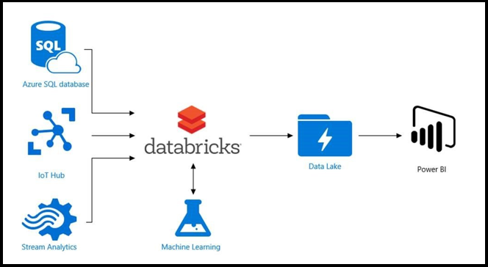

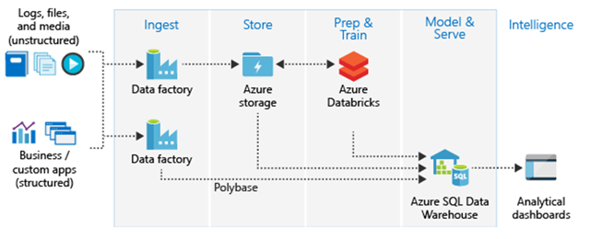

Create an Azure Synapse SQL Pool –Dedicated Sql pool

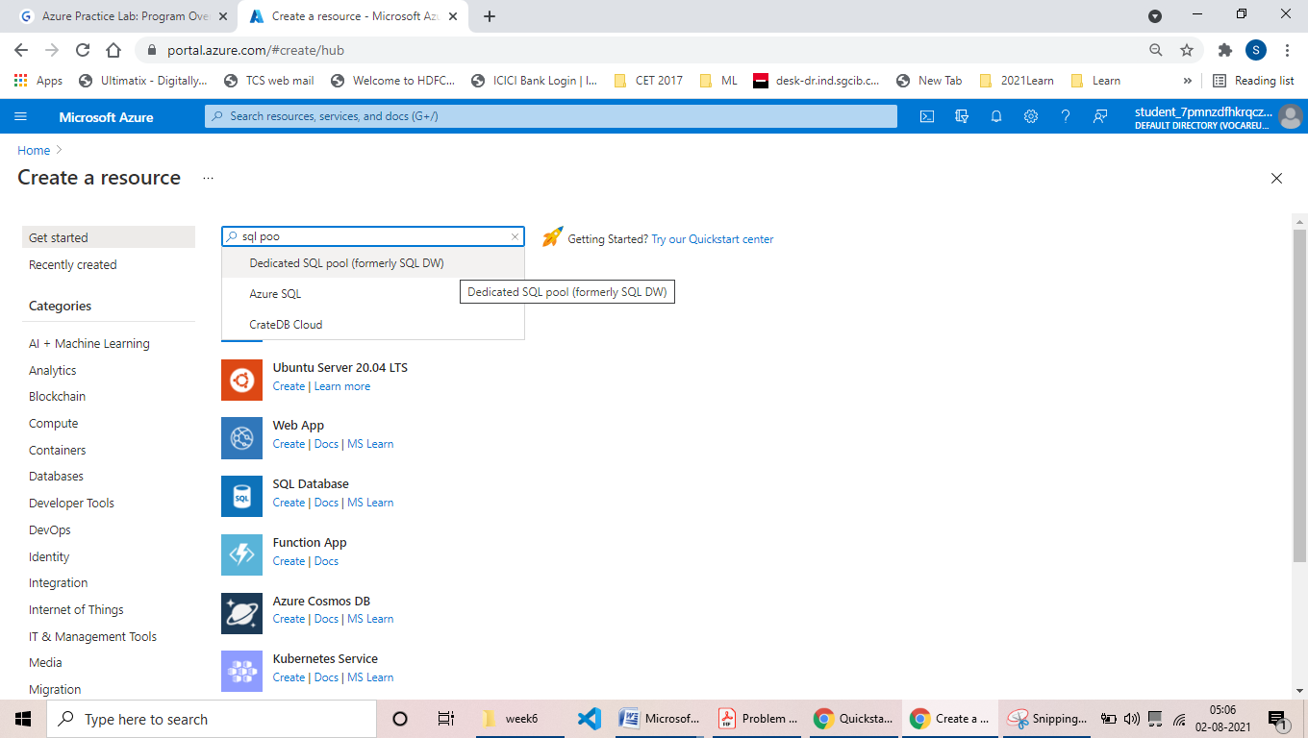
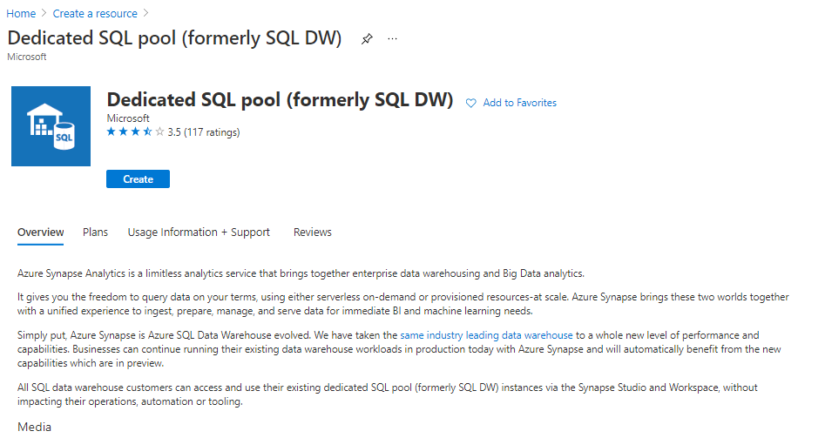
Create new server
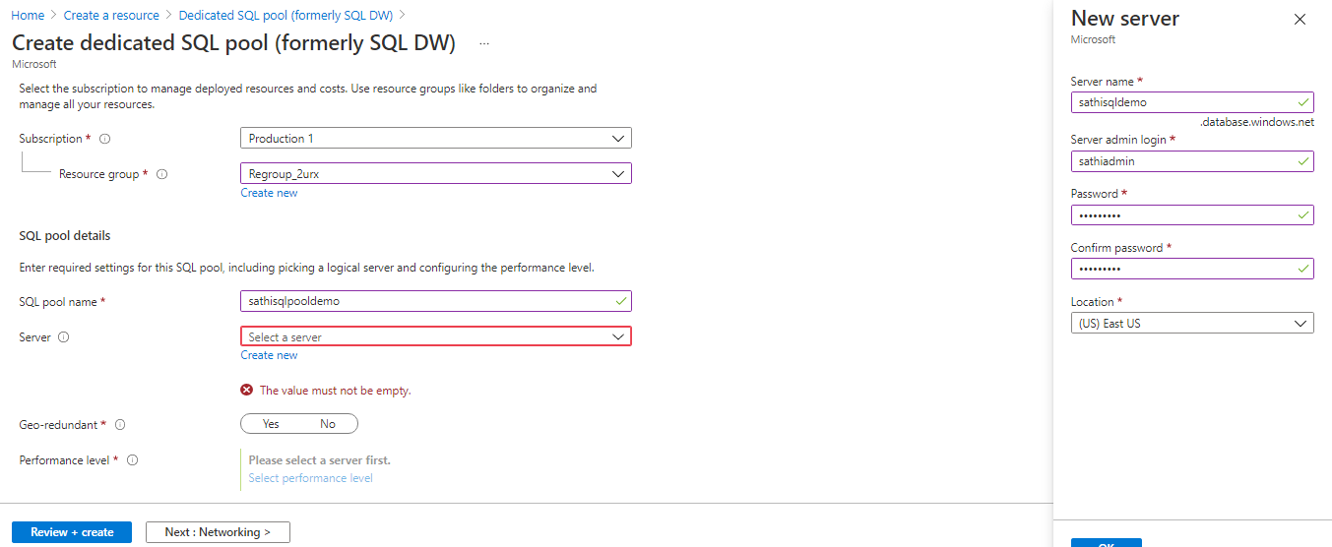

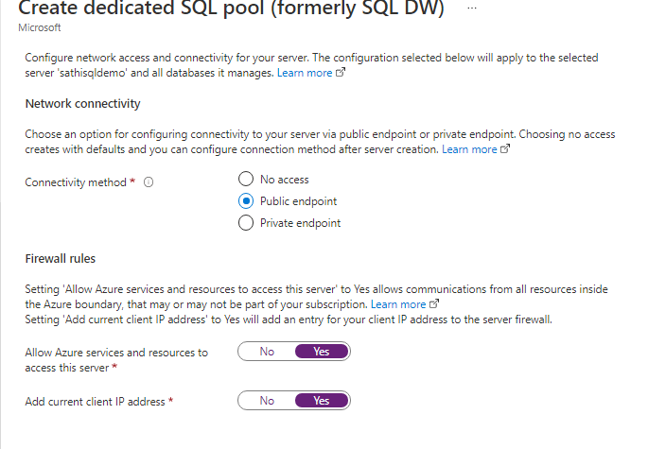
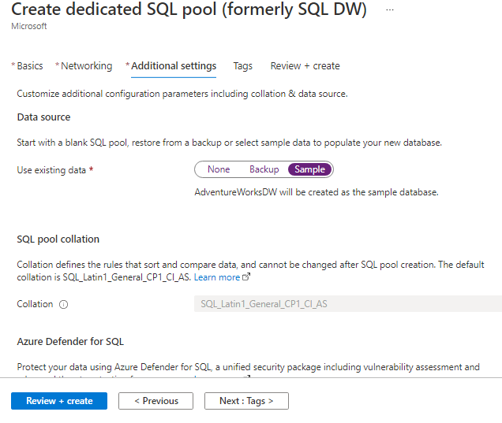
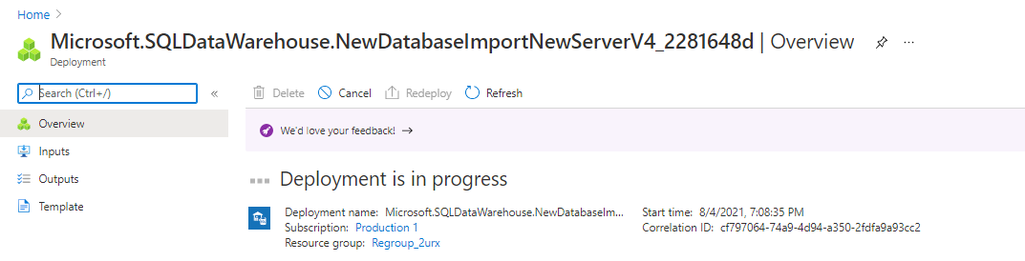
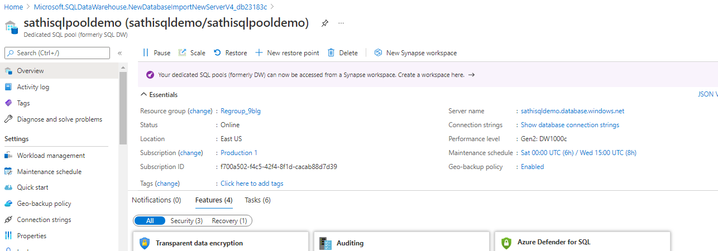

Create An Azure Blob storage account-Gen2 Data lake

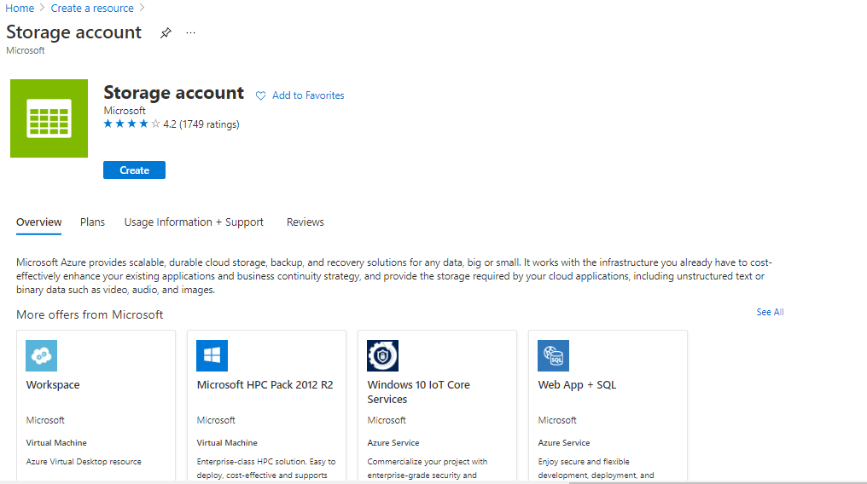

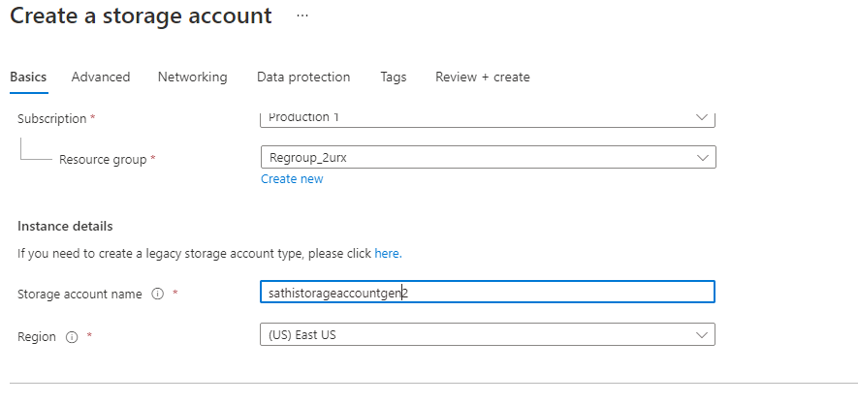
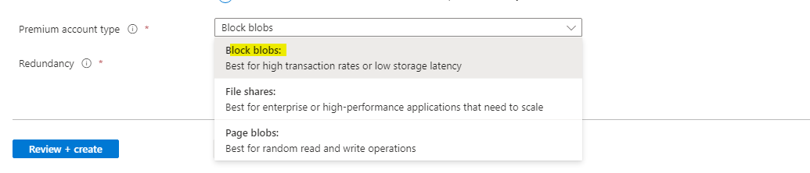
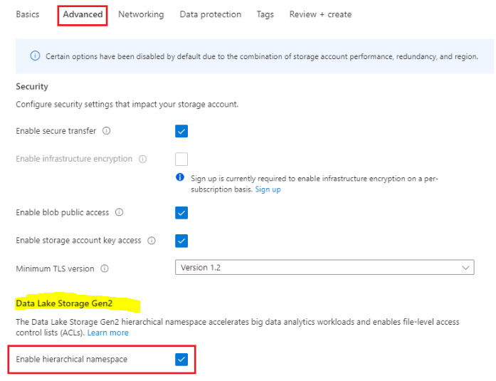
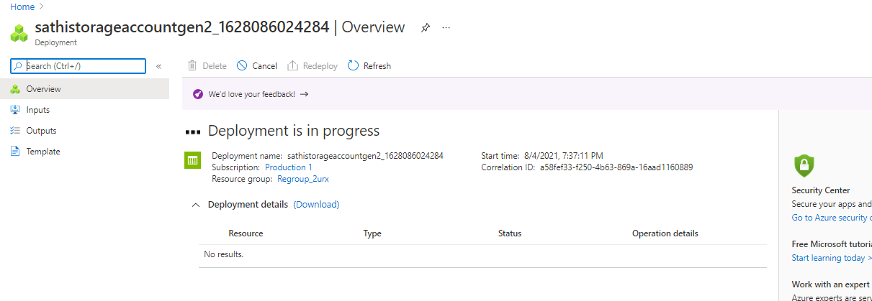
Create a container and upload json file
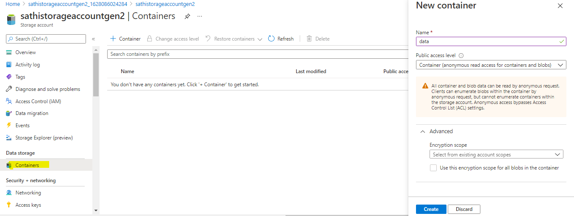

Load the following dataset into the storage account
https://raw.githubusercontent.com/Azure/usql/master/Examples/Samples/Data/json/radio
website/small_radio_json.json
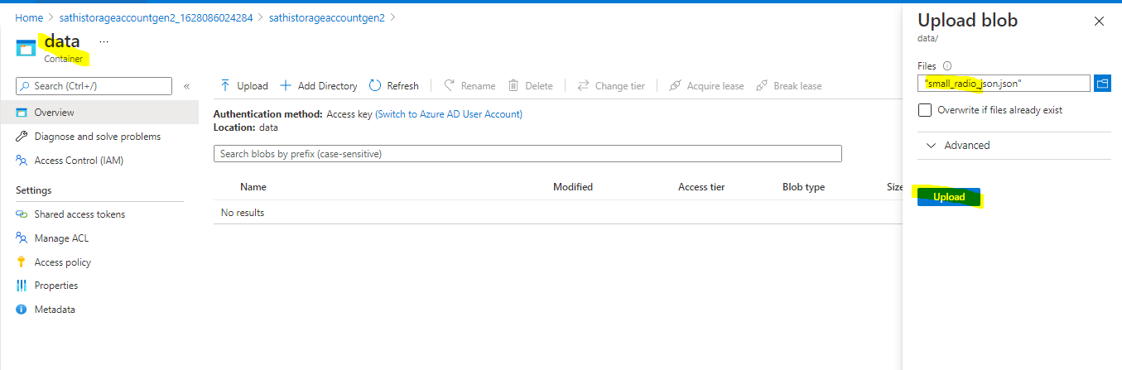
Azur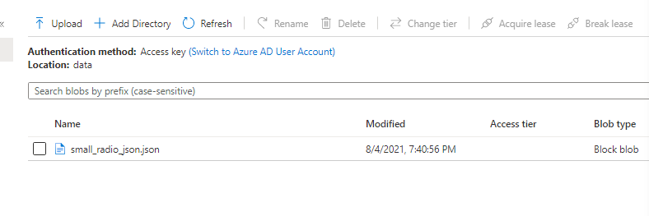

Create Azure DataBricks
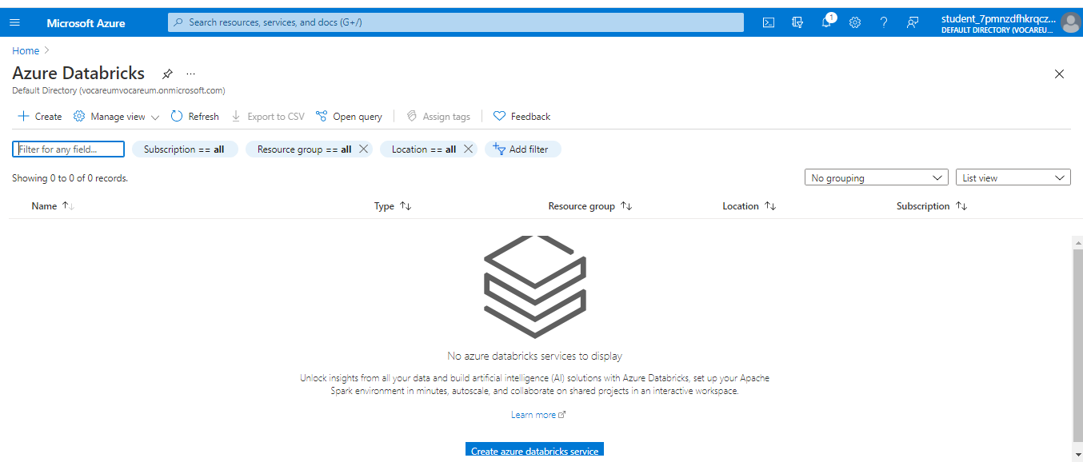
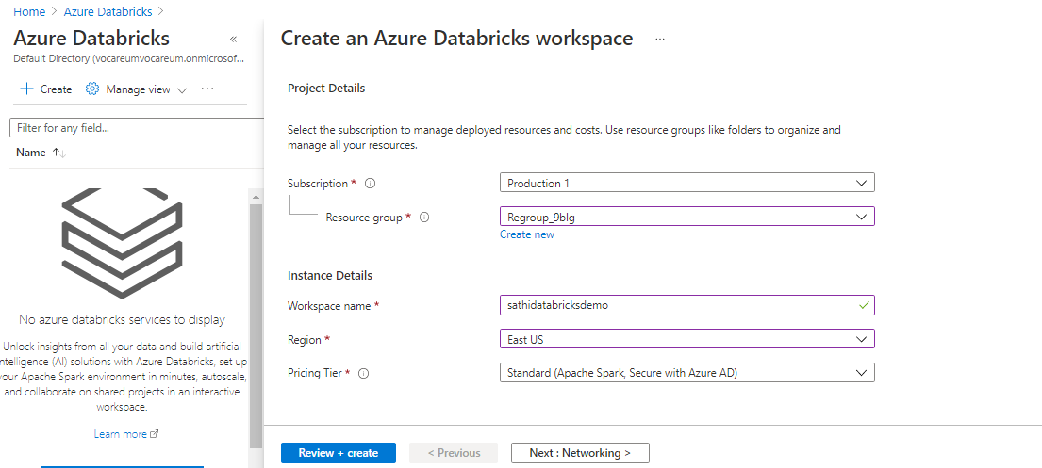
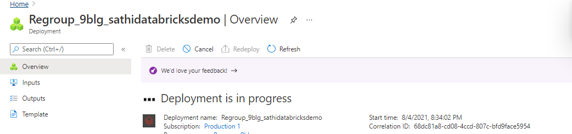
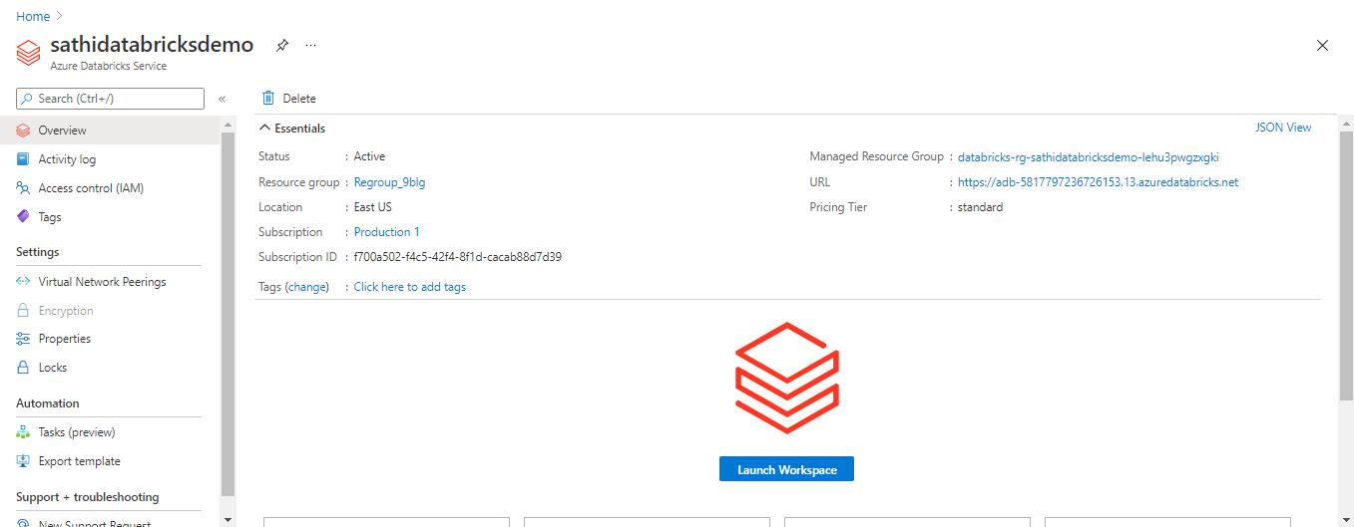
- In the Azure portal, go to the Databricks workspace that you created, and then click Launch Workspace.
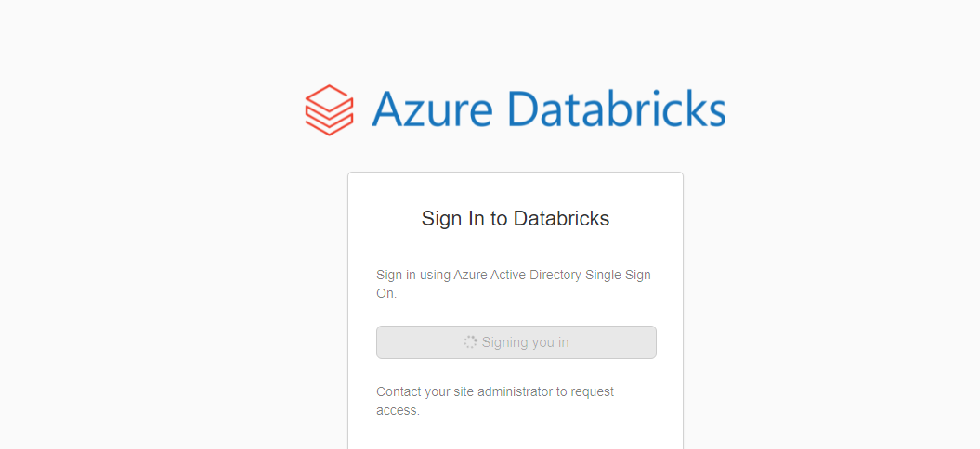
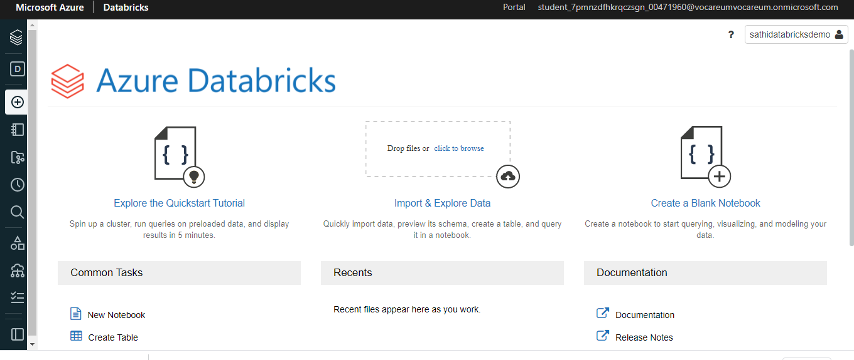
From redirected to the Azure Databricks portal. Click New Cluster.
Select Create cluster. Once the cluster is running, you can attach notebooks to the cluster and run Spark jobs
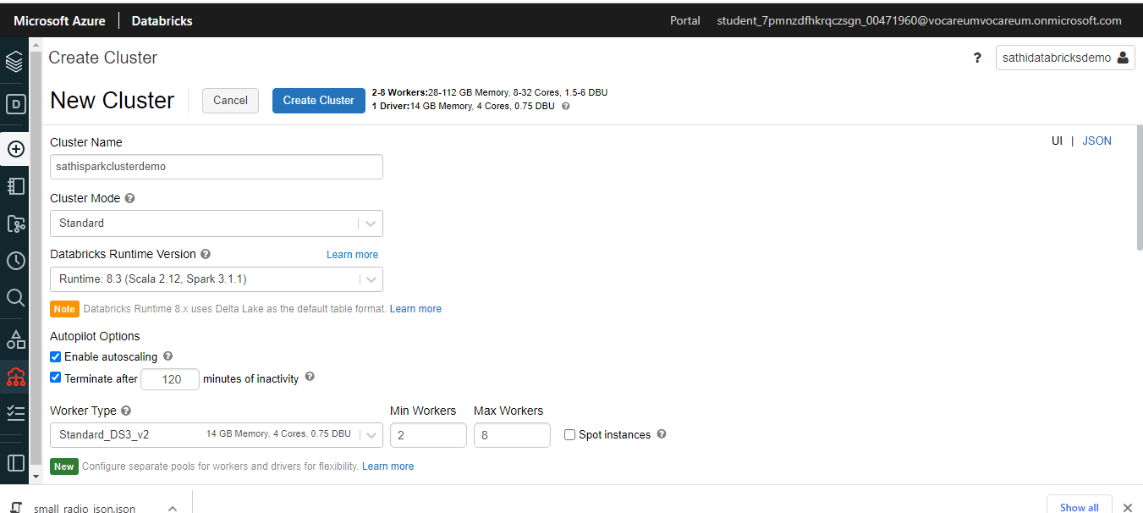
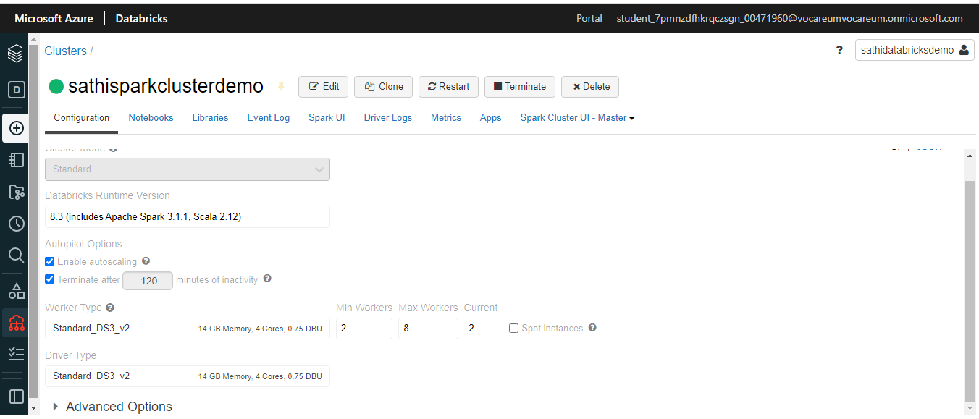
In the left pane, select Azure Databricks. From the Common Tasks, select New Notebook. Select the langugage that you wish to work on, later point of time we have option to change same
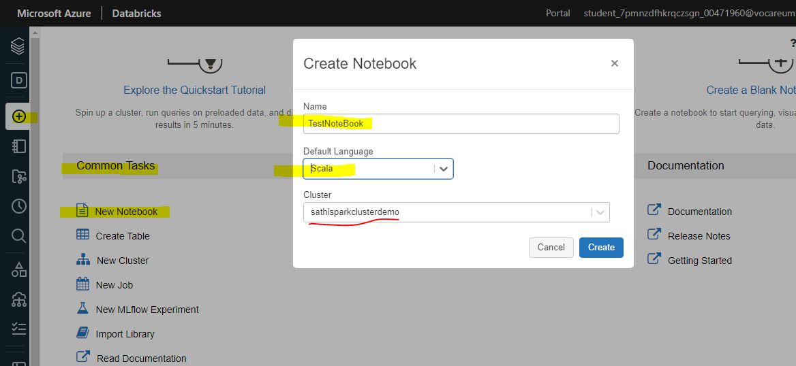
Generate sas token in storage account already created above , this is required as part of storage connection from spark cluster
https://adamtheautomator.com/azure-sas-token/
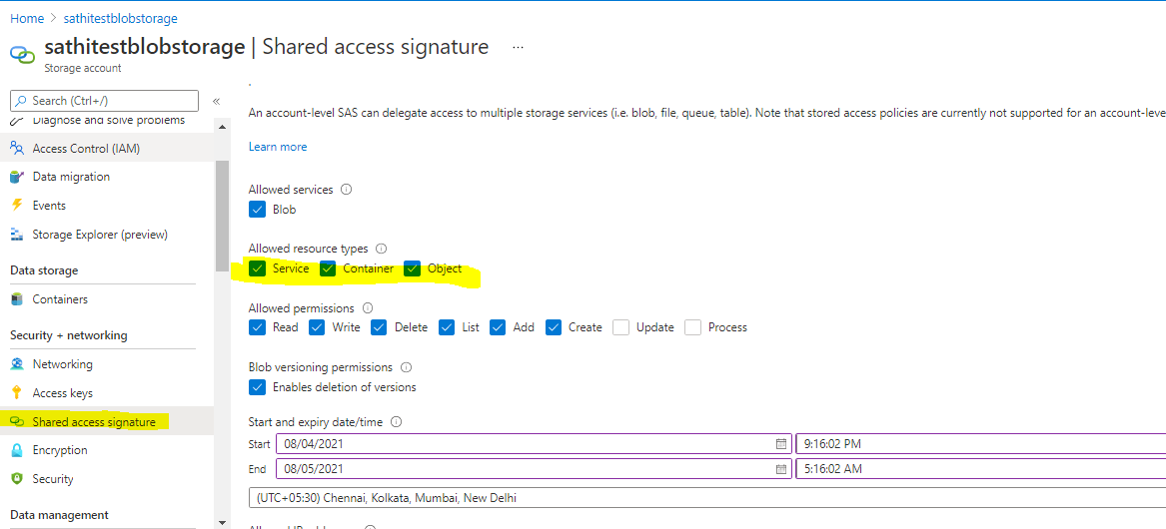
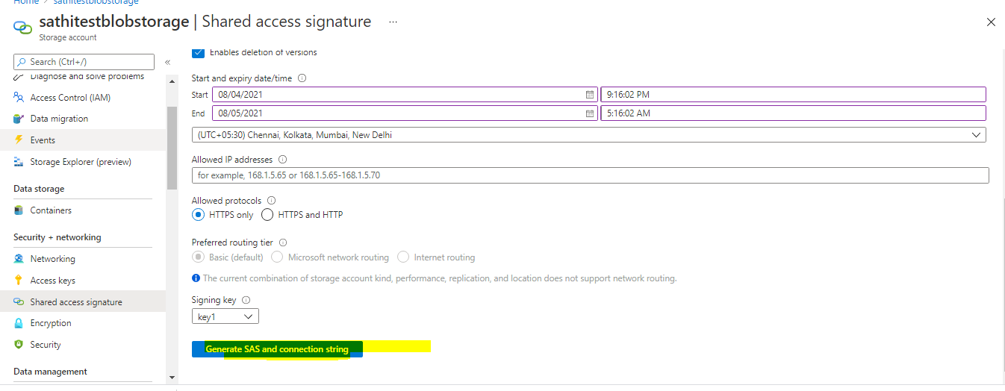
Copy for future refrence
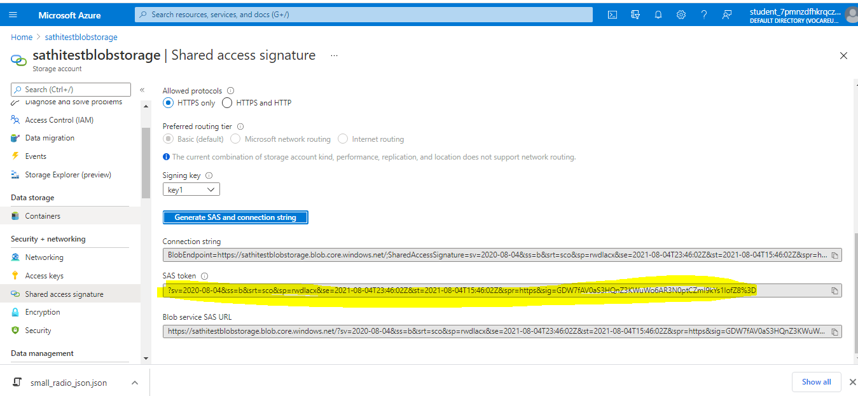
Copy uploaded json path for future reference
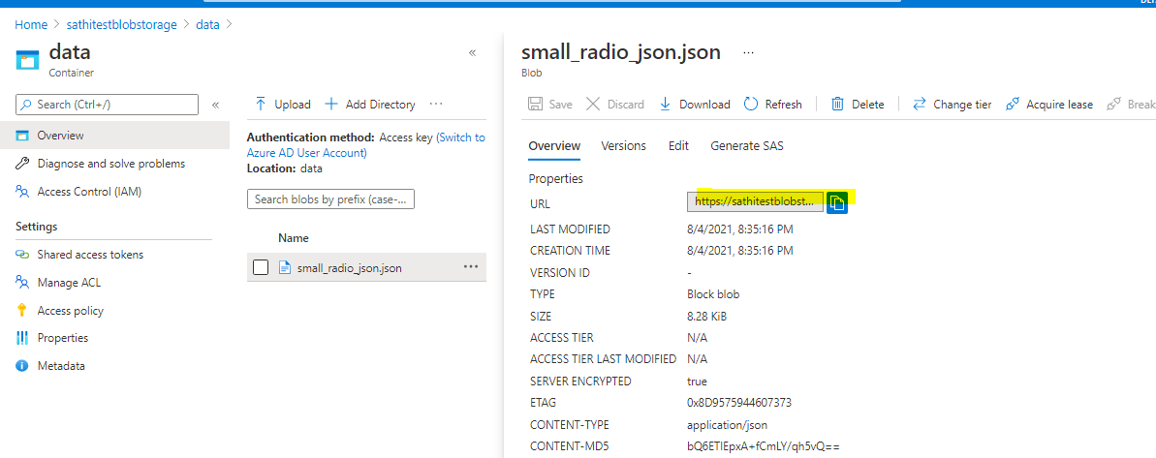
Change language to pythonin notebook
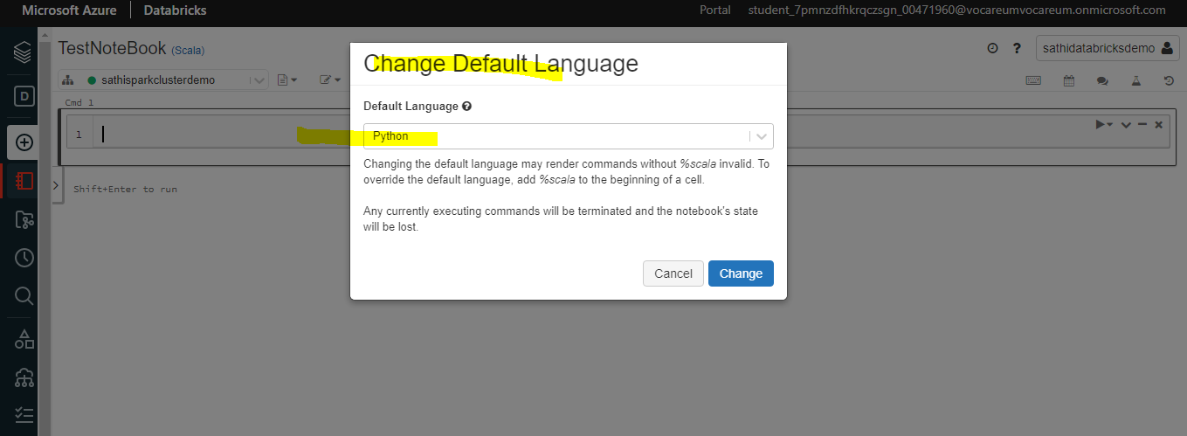
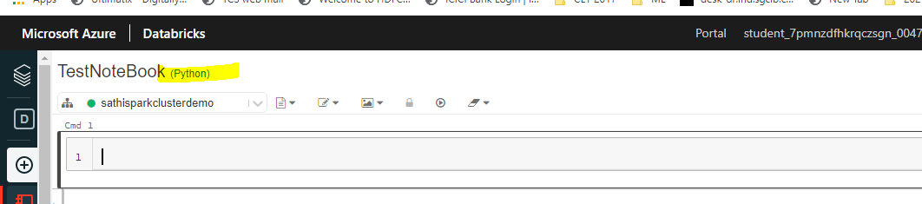

Extract the above json data into Databricks
Provide storage connection details
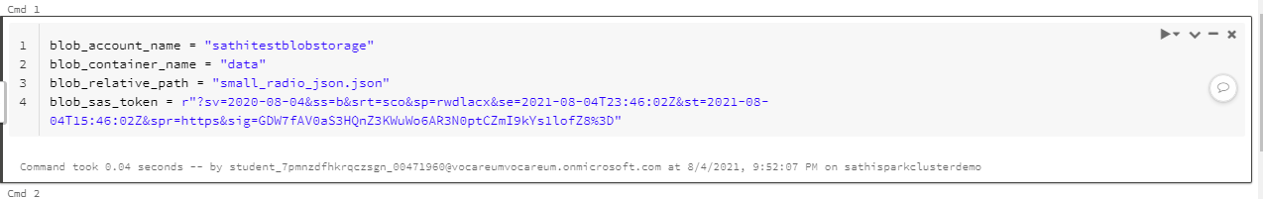
Create datasource path
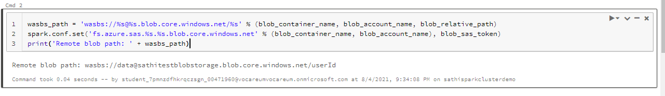
Load json file to dataframe
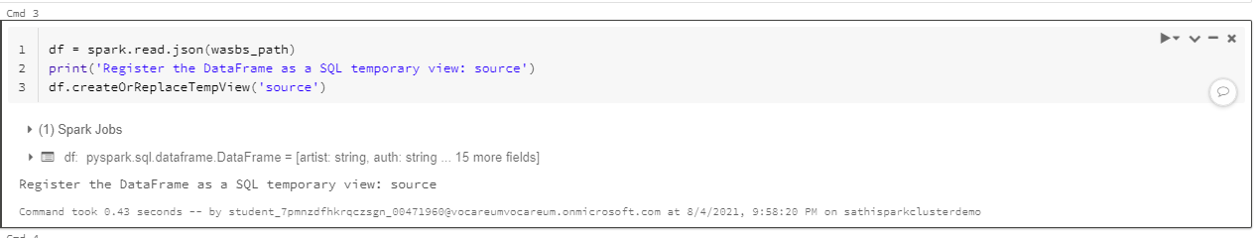
Query 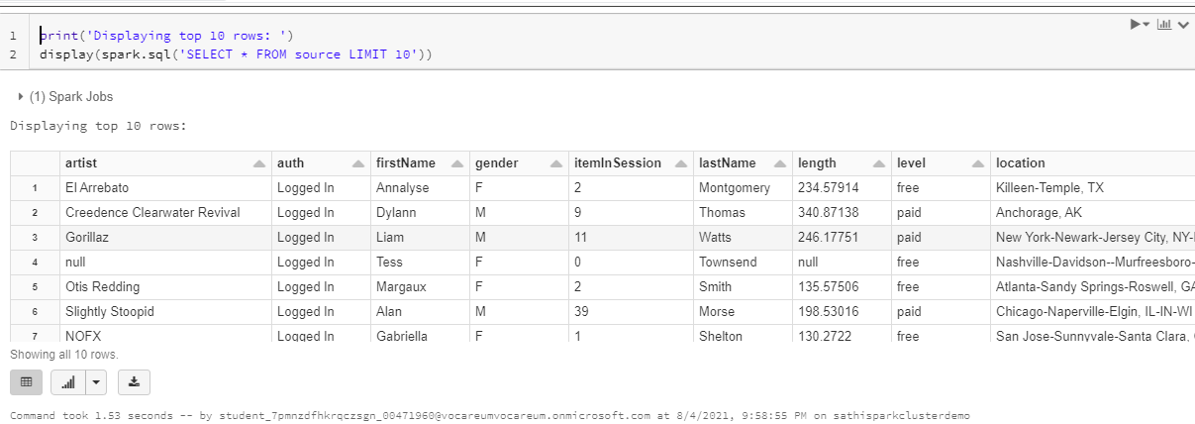

PLOT
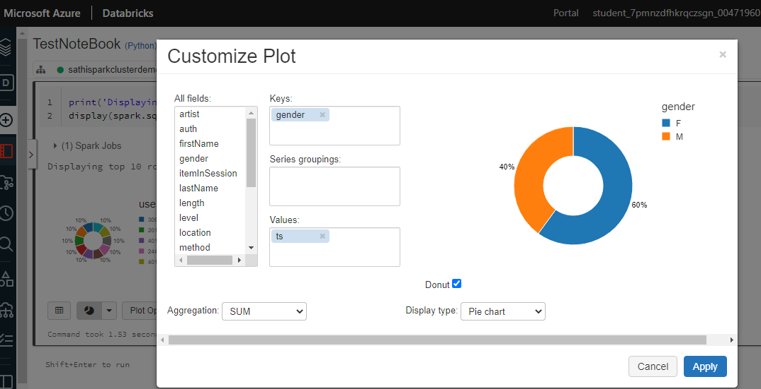
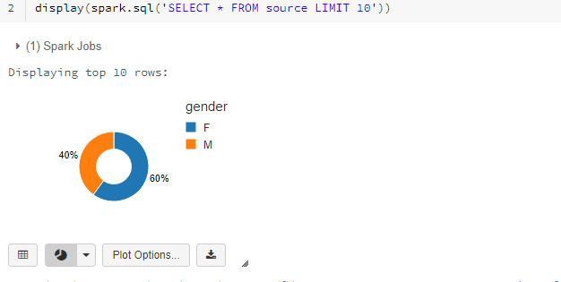
Rename the column “location” to address

df.withColumnRenamed("location","address").printSchema()
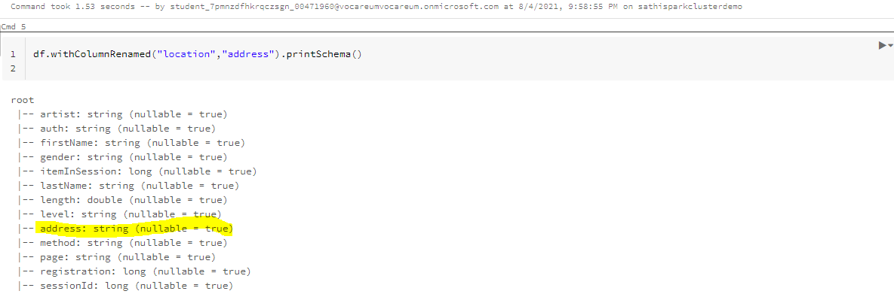

Load the transformed data into the created Synapse service
Edit json file in storage to make it simpler as below

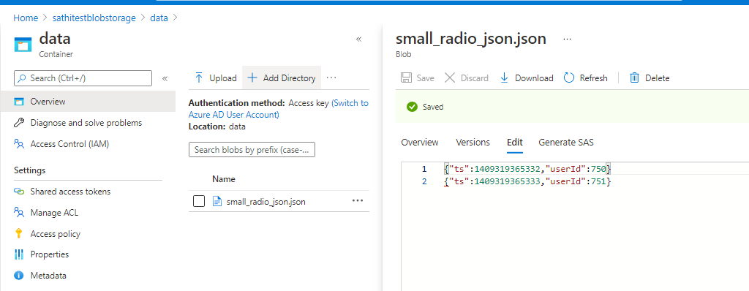
Copy sql pool connection string details created in first step

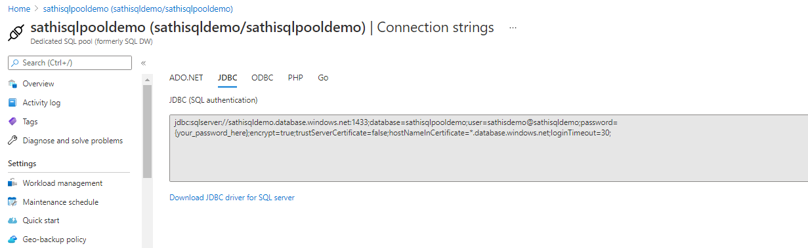
connect
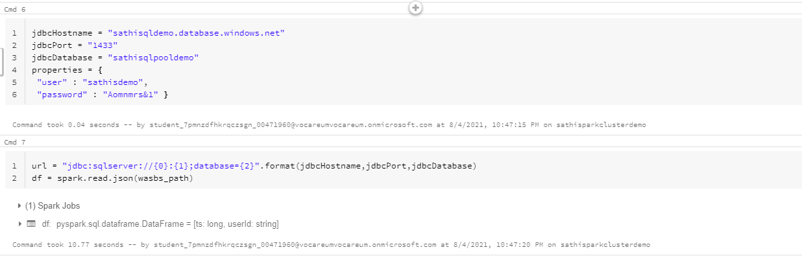
Verfiy loaded json data , dataframe and push data
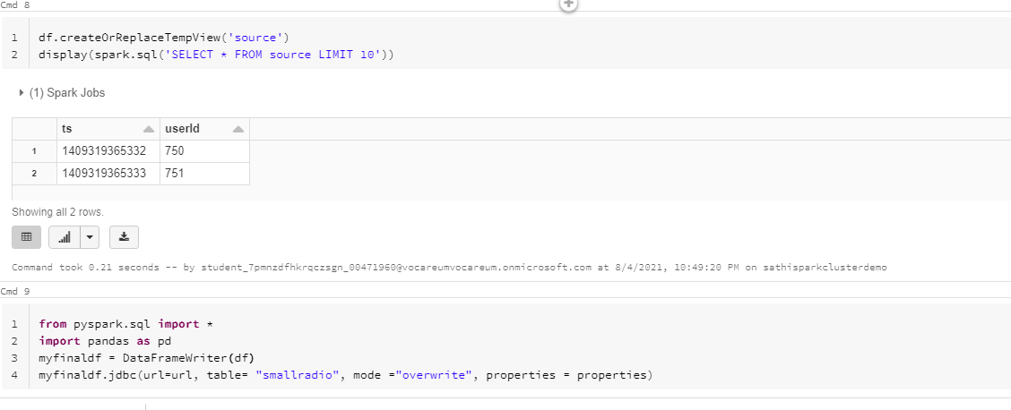
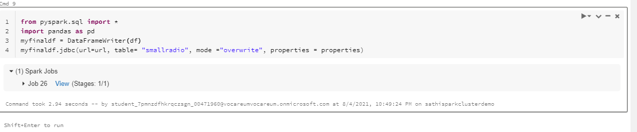
Verify published data in the pool by connecting to server to wich we have published
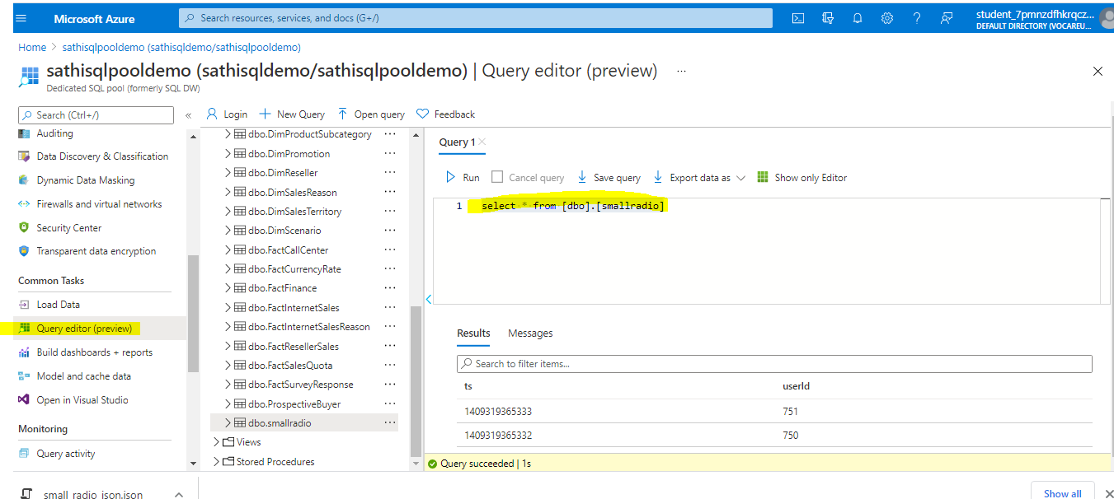

Refrences
Reference links:
1) https://docs.microsoft.com/en-us/azure/synapse-analytics/sql-data-warehouse/create-dat
a-warehouse-portal
2) https://docs.microsoft.com/en-us/azure/storage/blobs/storage-quickstart-blobs-portal
3) https://docs.microsoft.com/en-us/azure/storage/blobs/data-lake-storage-quickstart-create
-account
4) https://docs.microsoft.com/en-us/azure/databricks/scenarios/quickstart-create-databricks
-workspace-portal?tabs=azure-portal
5) https://docs.microsoft.com/en-us/azure/open-datasets/dataset-seattle-safety?tabs=pyspark

